**HOME STAY RESERVATION web application SYSTEM**

MISHAL SHAKINA RAJAMANICKAM

Academic project I report submitted in FULFILMENT OF the requirEmentS FOR the **Executive Diploma in Information Technology**

**CEntre for continuing education (UMCCed)**

UNIVERSITY OF MALAYA

Kuala lumpur

**2022**

Table of Contents

1. Admin-Panel 3

2. Staff-User-panel 5

3. Online Home Stay Reservation Web Application System 6

Dashboard,MainPage 6

***3.1.*** ***Module 1-Room registration*** 6

***3.2.*** ***Module 2-Room registration*** 7

***3.3.*** ***Module 3-Room service*** 8

***3.4.*** ***Module 4-Customer payment/check out*** 9

***3.5.*** ***Module 5-Customer information of check-in/out*** 10

# Admin-Panel

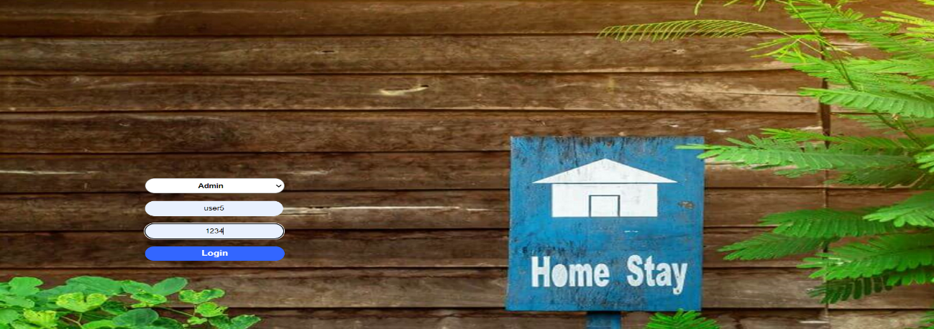

1. Select Admin from Dropdown
2. Enter Your Registered admin Username
3. Enter your password
4. Click ‘Login’ to enter the system
   1. **User Details**
5. Check the records of user after admin login.
6. Add Staff user
7. Delete Staff user’s login
8. Update Staff user’s login
9. Have all the privileges which staff user have
10. Go to Dashboard

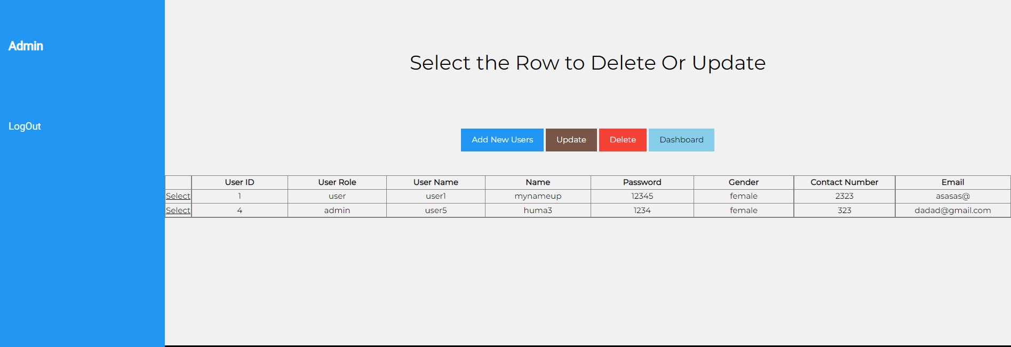

* 1. Add Users

1. Select the role(admin or user)
2. Enter the user details and sign up.
3. Click update to edit user details as I described above

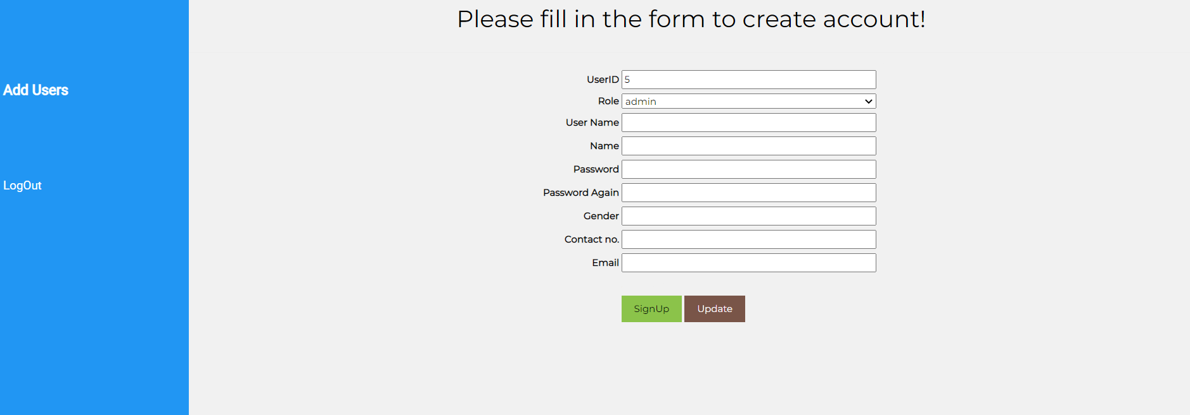

# Staff-User-panel

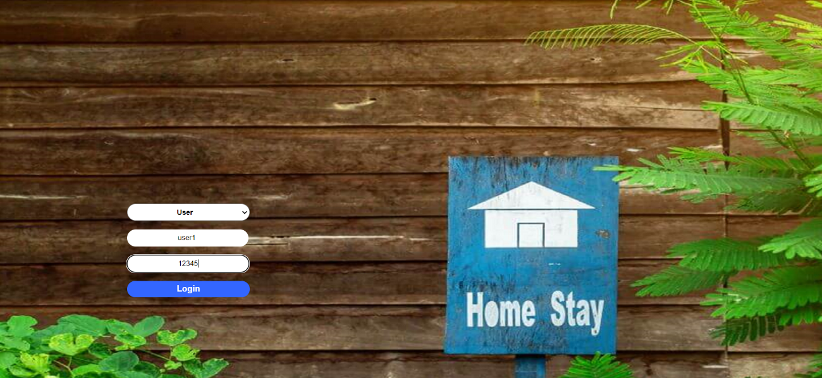

1. Select user from Dropdown
2. Enter Your Registered Username
3. Enter your password
4. Click ‘Login’ to enter the system

# Online Home Stay Reservation Web Application System

# Dashboard,MainPage

## **Module 1-Room registration**

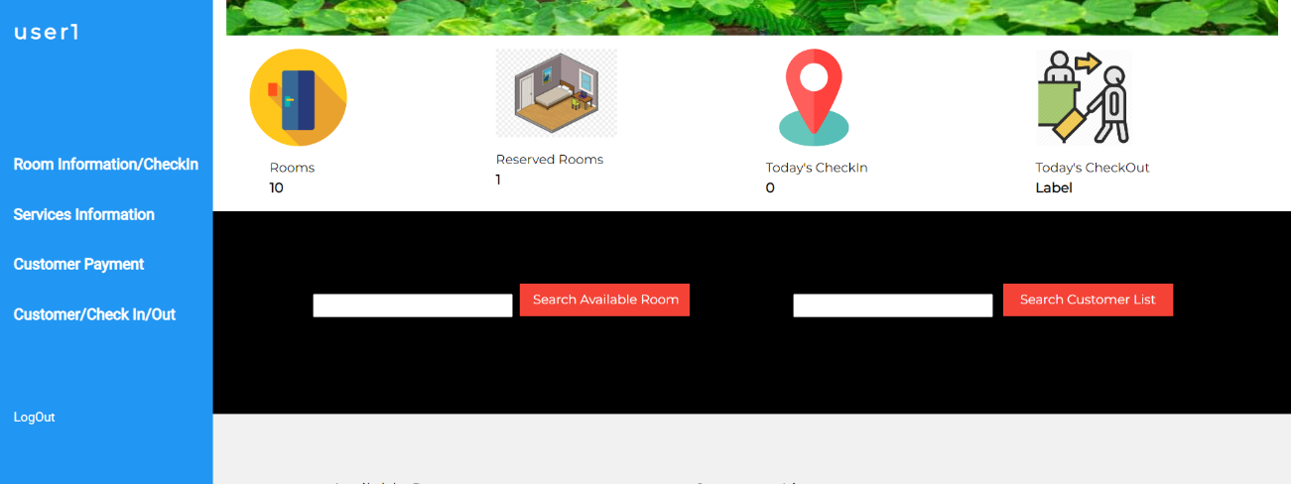

1. Rooms which are reserved.
2. There will be check in records of those who check in today.
3. There will be a record of checkout guest.
4. There is data gird which will have the list of available rooms.
5. There will be a list of customers which are in home stay.
6. You can search customer and available rooms from Dashboard

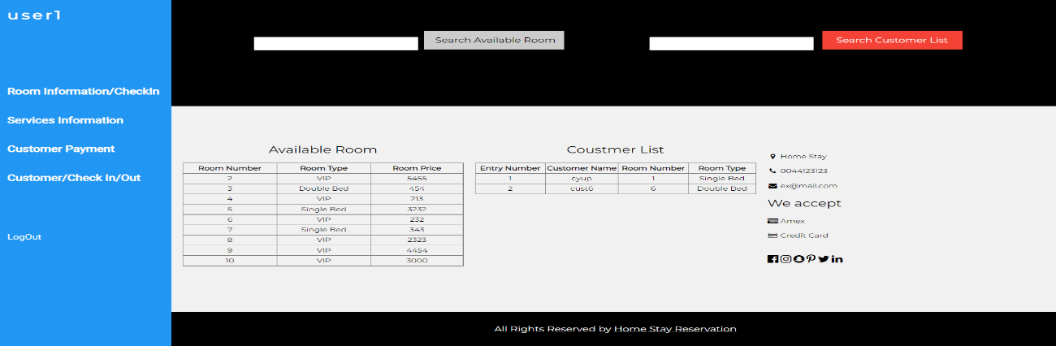

## **Module 2-Room registration**

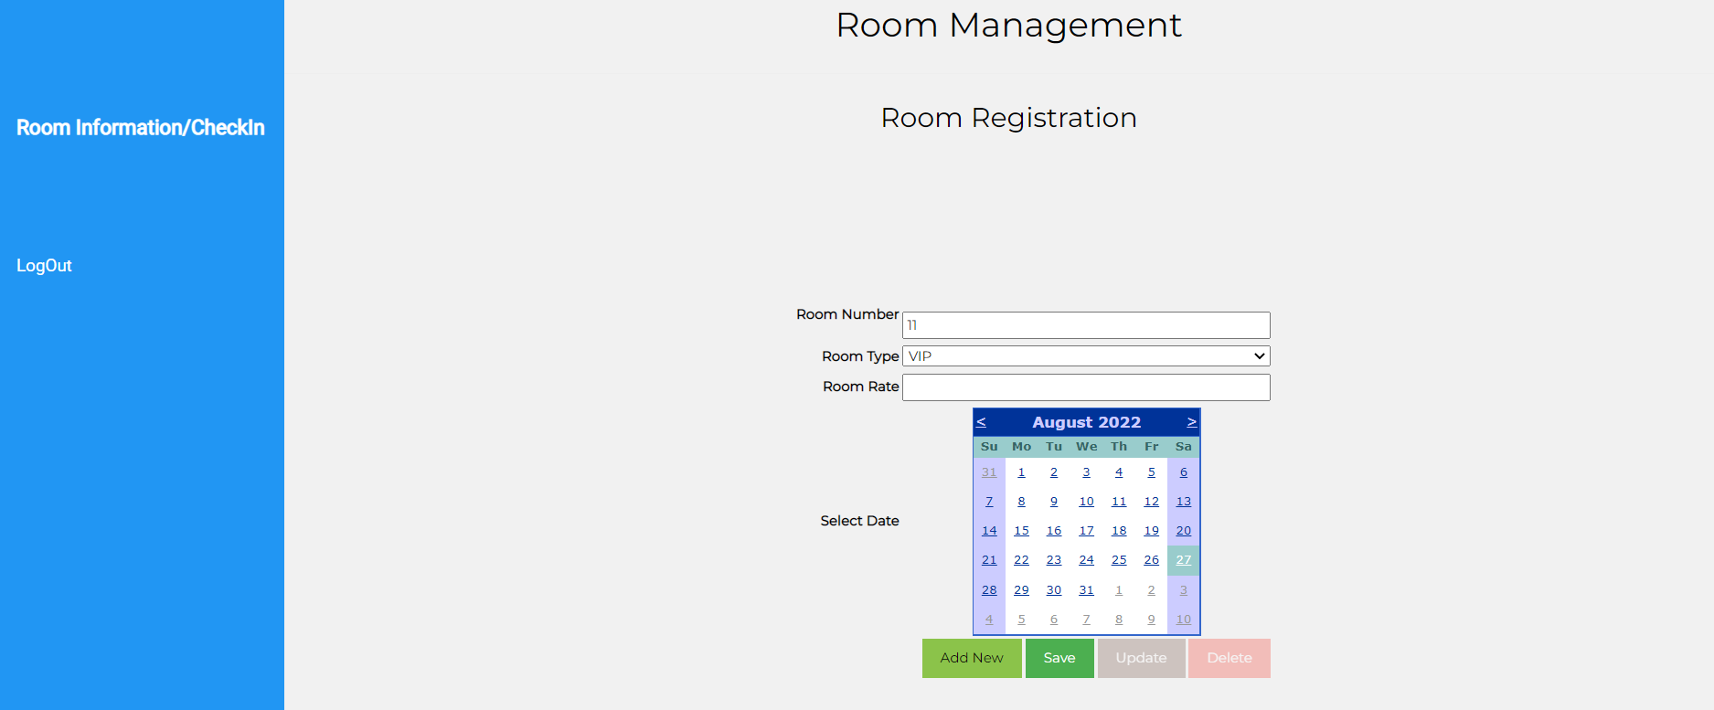

1. The rooms will be registered in this module.
2. There will be a grid which show the data of available rooms. The employee will select the room from list according to customer requirements.
3. Check the status if the room is available or not.
4. There will be a search box which help to filter the customer information who reserved the room.

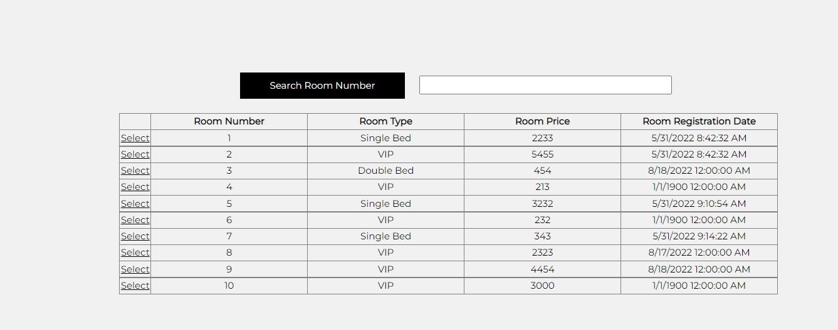

## **Module 3-Room service**

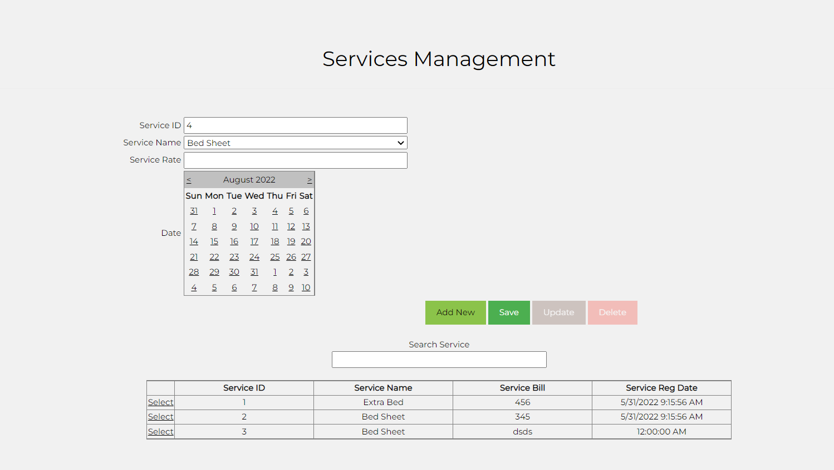

1. There will be a form which is for registration of services. The services, which are used by guest will be add from available list.
2. You can add, update and delete services.
3. There is a record of services you can search them by textbox.

## **Module 4-Customer payment/check out**

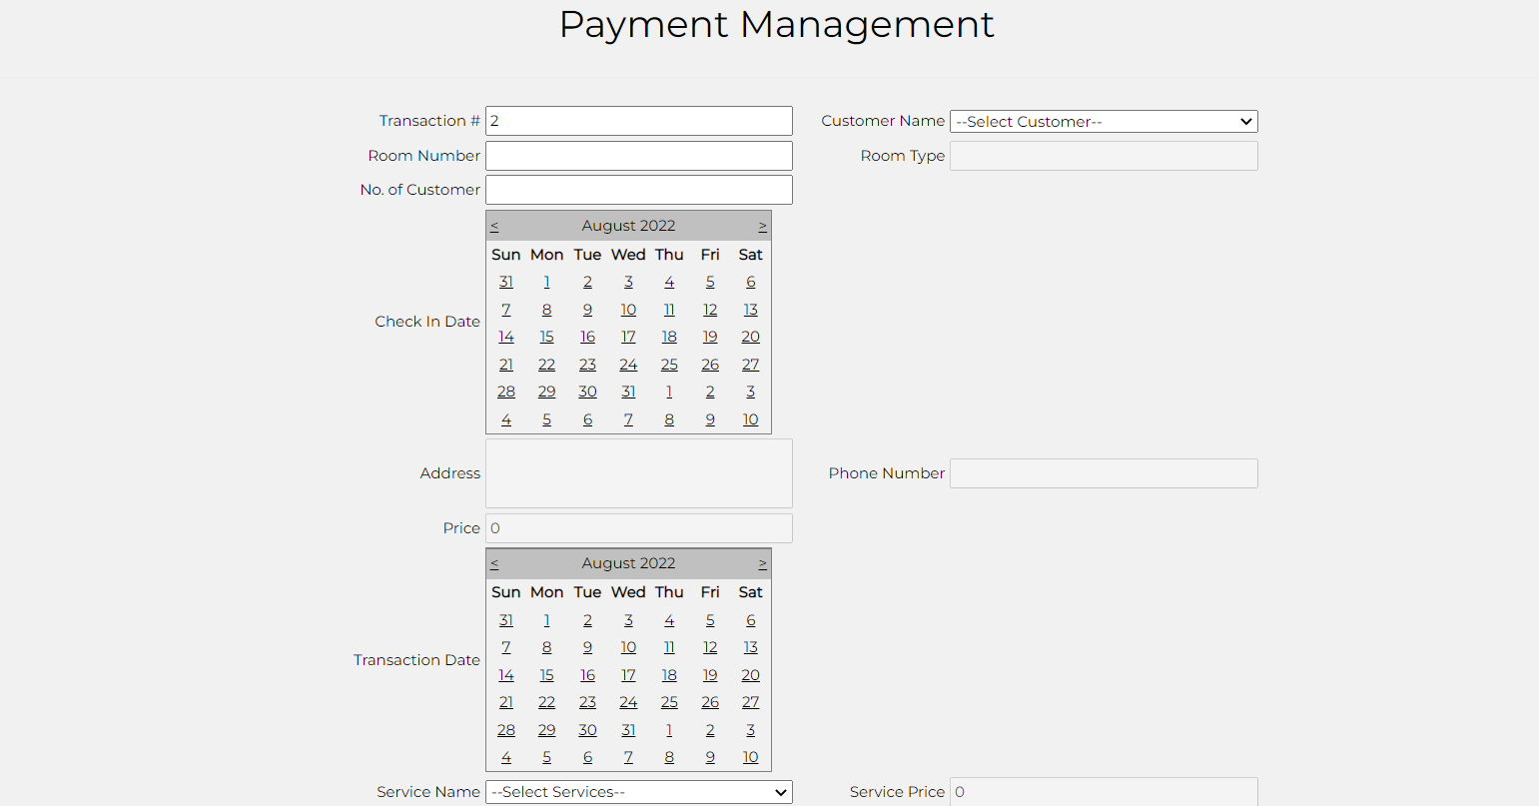

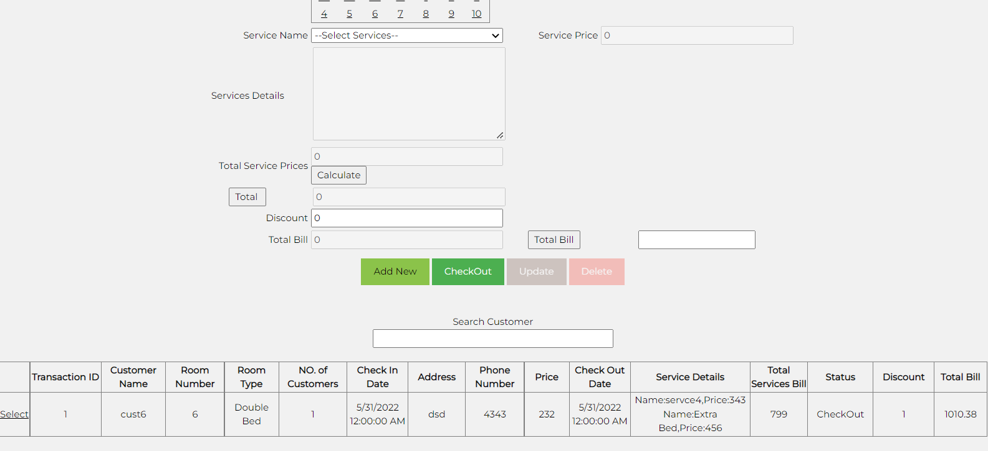

1. In this form, customer data will be retrieved from database. The room charges and services charges will be added in this web form.
2. There will be function of discount (if any).
3. Finally, the room price, service and discount will be added and total bill will be generated.

## **Module 5-Customer information of check-in/out**

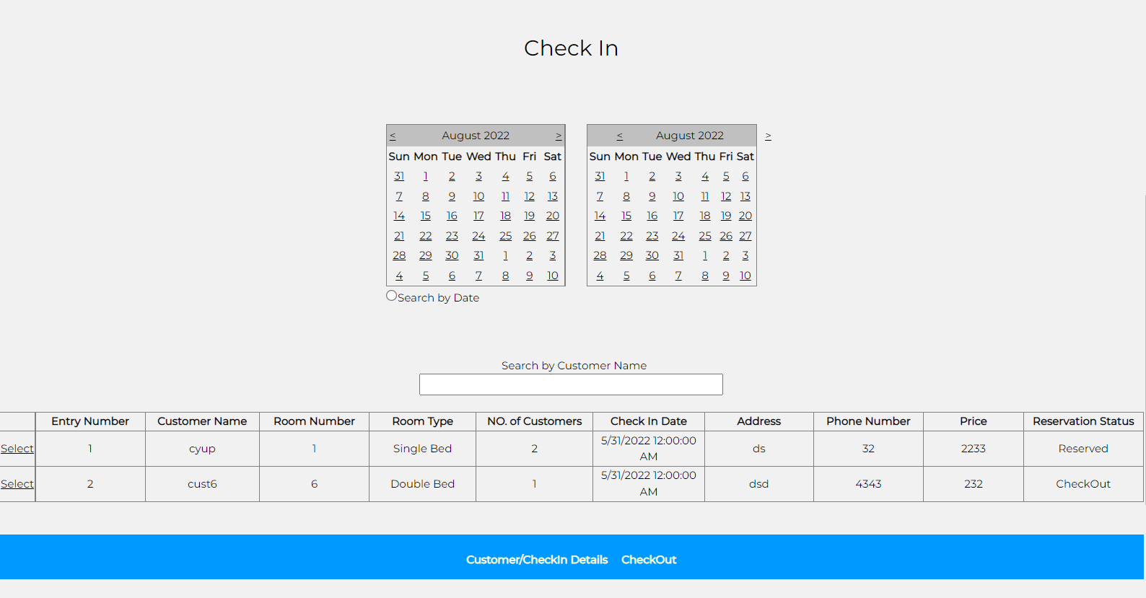

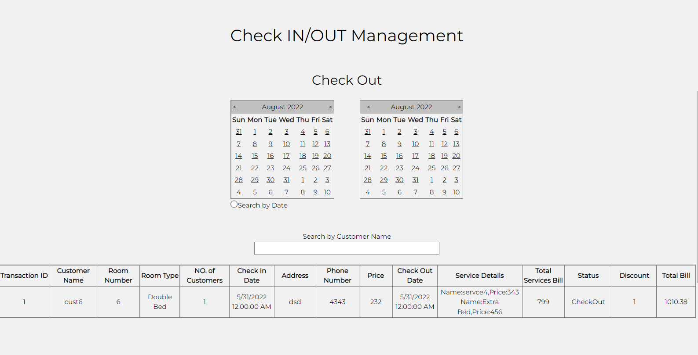

1. It shows the information of all customers.
2. It also will have the information of checkout/check in customers.
3. There will be a filter for customer name search.
4. There will be date filter to see the records.